On the Theoretical bounds of the Spanning Tree Algorithm
Eduard Bonada, Dolors Sala
Networking and Communications Research Group (NetCom)
Department of Information and Communication Technologies
{eduard.bonada, dolors.sala}@upf.edu

Abstract — The Spanning Tree Algorithm is the base of the link layer protocols like STP or RSTP. These are used in Ethernet bridges networks to eliminate loops by building a logical communication tree on top of the physical network. Even though it is an automatic and robust algorithm, its recovery time is too large. And as Ethernet is being extended to provider networks applications, very strict requirements on network recovery are imposed. This paper presents an analysis of the STA behavior in order to identify the theoretical limits of its convergence. An expression of its lowest bound and further simulation analysis to validate it are given. With a detailed and concrete analysis a final conclusion that identifies the key elements that determines the tree creation time is provided.

I. Introduction
Ethernet has become a dominant technology and it is now a universal communication interface more than just an access technology. Its low cost, high data rates and low complexity and maintenance offer Network Providers a good opportunity of using Ethernet data networks at very large scale replacing the existing ATM/SONET or IP networking [1]. Since this new environment means new requirements, some aspects must be reviewed. For instance, transporting cross-provider traffic through these large networks involves a set of Service Level Agreements (SLA) to be met. This means the use of tighter control and management capabilities than in traditional Ethernet. One of the more strict SLA requirements is that the maximum network recovery time must be lower than 50 ms, and the original Ethernet does not meet it.
Ethernet networks are built using layer 2 bridges [2]. One of the basic bridge functionalities, following the Ethernet philosophy, is the broadcast service. Together with the existence of loops in the physical network connections, the broadcast leads to an undesired situation with a congested network and configuration instabilities. Note that a broadcasted frame (to be sent to all nodes) may enter into a physical loop. Then, it is endlessly forwarded by all bridges in the loop creating duplicated frames and saturating the network links. In order to avoid loops a technique that builds a loop-free active topology on top of the physical network is used. The IEEE standard [3] proposes the Spanning Tree Protocol (STP). It is a link layer protocol defined in the 802 architecture that builds a tree active topology (note a tree does not have loops). Regarding the aforementioned SLA requirements, the main STP drawback is that it blocks data connectivity while it is configuring the tree and this action takes too much time (tens of seconds). An evolved version is the Rapid STP [2]. It highly decreases this time, but it is still far from the required 50ms in some failure situation.
There are other aspects of the STP performance that become really important in the new environment. The use of a tree-shaped active topology automatically avoids some of the links to be used. In large scale networks, where efficiency and performance are essential aspects, the use of links either for redundancy or capacity reasons must be considered. In addition, using Ethernet technology in provider networks introduces other aspects like security, QoS provision, Traffic Engineering. A lot of work is in progress to adapt the original technology and meet the new requirements [4][5].
We study of the fundamentals of the protocol in order to completely characterize them, understand their operation and identify the problem from the base. Both STP and RSTP are based on the Spanning Tree Algorithm (STA) [6]. The STA is a distributed algorithm simple from the node point of view but very powerful from the network operation perspective. The algorithm lacks of a condition to tell the same nodes when the tree is totally created so they can start sending data (note that this action should take less than 50ms). This work has involved a rigorous observation of the procedure and a simulation analysis to help on this study. We provide a theoretical lowest bound of the convergence time adjusted to the real topology characteristics. This value can be used as a reference to evaluate protocol performance (e.g STP is far from the bound while RSTP approaches to it in some situations). A simulation analysis is used both to validate the theoretical bound and closely analyze detailed elements of the algorithm. The main conclusion of the deep study is the identification of the key element of the tree creation process: the size of the tree that is going to be built and the location of its root.
This paper is structured as follows. Section II presents a brief description if the STA operation defining its elements and main processes. Section III analyses the behavior of the algorithm in the tree construction phase and provides the theoretical bound. Section IV includes the simulation analysis and the discussion that leads to the main conclusions in section V.

II. Description of the STA Operation
The STA creates a tree (loop-free) active topology on top of the physical one. There is a unique node that is considered the Root of the tree while others form the branches. The algorithm creates a spanning tree, hence the Root and each one of the other nodes are always connected through the shortest path (a tree branch). Moreover, at each network segment (link) there is a node that acts as the owner and is the responsible of connecting that segment to the Root. Note that there must be only one responsible node per network segment in order to avoid loops.
The STA is a distributed algorithm where each node executes the same operation. The objective of the algorithm is that each one of the network nodes independently decides which of its ports are active (belong to the tree) and which ones are blocked (de not belong to the tree). Note that the blocking of a port results in blocking a link and in turn breaking a potential loop. These local decisions are based on the immediate neighbors’ information and always oriented to locate the Root and the distance to it. In doing so, a node is always trying to configure itself to use the shortest path to the Root (a tree branch). At the end of the configuration, the algorithm assures that the local decisions are totally consistent from the network point of view and at this point the tree is created and loops are broken.
Each node of the network has a unique ID. The lowest ID is the Root of the tree. The node state includes: 1) the node assumed to be the Root, 2) the distance to the root (cost) and 3) the state of the ports (active/blocked). This is a simplified view of the state but enough for the scope of this text, for more detailed information refer to [4]. Figure 1 shows an example of a final tree configuration marking the blocked ports with X. Regarding the state, observe that node 2 knows that 0 is the Root and that it is located at distance 1 (one hop).

The state information is exchanged between immediate neighbors by sending special messages (BPDUs). A BPDU includes the assumed Root, the cost and the ID of the sending node. These messages are processed at reception and the information is compared with the node state. Figure 2 shows the pseudo-code of a node operation to process a receiving BPDU. Basically, nodes change state if the received BPDU is considered better (or superior). The receiving node decides it is superior if the BPDU carries a lower Root ID or the same Root ID and a shorter path to it (lower cost). In case of tie, the lowest (sender) ID is considered better. In the case the BPDU is superior, the node updates its own state and sends BPDUs to the other ports in order to inform the neighbors. If the received state in the BPDU is considered inferior (higher Root ID or longer path), it replies with a BPDU containing its own superior state in order to disseminate its winning state to the sending node. When the received and current state is the same, the information does not change and nothing is done. At this point propagation of information at this node stops until it notices of new updated information (superior BPDU) and starts the process again.
The tree configuration is based on a succession of node state changes. As BPDUs are being sent and processed, nodes keep updating their states always upgrading to the best information they receive. When the tree is entirely configured, each node has a final state that includes the lowest node ID as Root, the port with the smallest cost to the Root and the responsibility to the downstream branch. Note that before this condition the node may be in a transient state believing on information that is eventually updated by a later message. However, a node is not able to decide by itself when it gets this final condition. A single node does not know if the received information is final or a better BPDU is going to update it. In addition, BPDUs as keep-alive messages are being sent continuously (note that these BPDUs are eventually considered as repeated by the nodes). Because of the distributed nature of the algorithm, nodes only react to what they receive. In other words, a node makes decisions based on what neighbors send, which is only local information of its surrounding. This fact implies a difficulty from a wider network perspective when trying to decide at which point the tree is entirely configured. There is not an explicit decision, neither centralized nor disseminated, that notifies the completion of the tree configuration. Hence the detection of this final state is very complex. Section III describes the tree configuration process and addresses this problem.

If BPDU is better
Reconfigure node (update node state)
Disseminate new information
send BPDUs to neighbors
If BPDU is worse
Reply with (my) better information
If BPDU is the same
Nothing is done

Fig. 2. Pseudo-code of the STA operation after receiving a BPDU
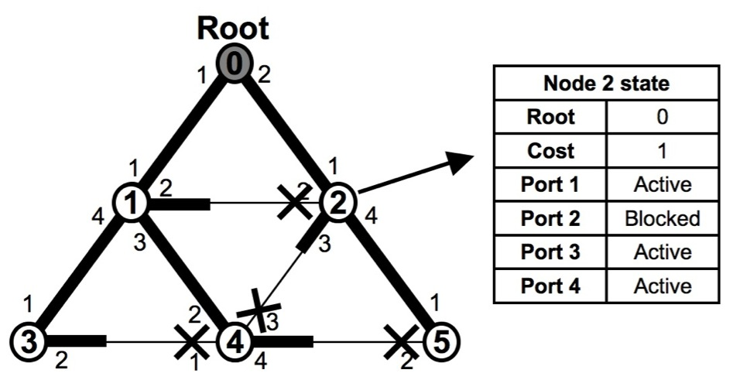

Fig. 1. Configuration of an active tree over a physical network

III. Creating the Tree: The Propagation Effect
At the network startup all nodes believe themselves to be the Root and start sending BPDUs telling their state. At this point all ports are considered to be potentially active, which would lead to the creation of many loops. The BPDUs are being received by all neighbors and the state changes start. An easy and graphical way to see this effect is considering that each node starts propagating a wave containing its state (announcing themselves as the Root).
Figure 3 shows an example. The black node is elected as the Root (lowest ID) of the tree and the grey and squared nodes start their own front-waves that are eventually beaten by the black one. When two neighbor node waves encounter, the wave with the lowest Root/cost is considered better, beats the other wave and continues its propagation while the defeated wave stops at that point. This comparison is done whenever two waves are faced and the winner always gets through (in the figure, the black wave wins the squared wave). The key point is how the wave that starts in the node elected as Root advances. This wave is always considered better than the others and keeps on propagating until it covers all nodes. At this point, all other waves have dissipated and no more state changes occur in the nodes. The tree is finally configured (in the figure, all nodes have received the black wave from the Root).

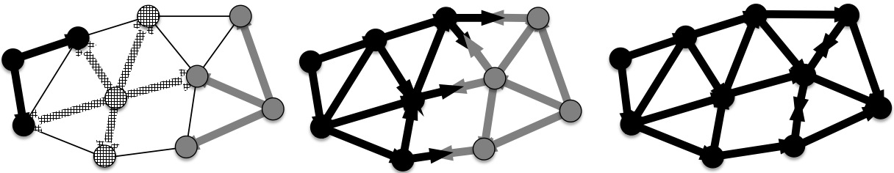

Fig. 3. Propagation of the state (front-wave) and the winning Root information

It is very easy to observe that when the propagation from the Root covers the entire network the tree is ready, the loops are cut and nodes can start sending data. This behavior based on the propagation of the Root node is very easy to model. The following derived expression gives the value of the convergence time (time until the tree is configured).
Where t_{hop} is the delay of one hop and n is the number of hops from the Root to the furthest port, following a shortest path (this is the longest branch). Assuming there are d nodes in the longest branch, n = d − 1. In the example of figure 3, n=4 because the longest branch has length 4 hops (5 nodes).
This situation can be easily observed from the network perspective but it is extremely difficult to control and detect from a single node. The algorithm assures the nodes are always configured with the best state (best path to the assumed Root), but they never know if that state is final or transient. Note that n is not known a priori as the tree is not formed yet. The shortest paths, hence value of n, can be derived with a network perspective but this information is not available to the nodes. However, we can model the system and take optimal decisions in simulation to define the theoretical bounds.
Another interesting observation is that the branches that form the tree follow the shortest paths between the Root node and all the others. The way the algorithm performs its execution leads to this situation because each one of the nodes, at each reconfiguration, tries to connect to the Root through the port with the shortest cost to it. The STA is a distance-vector algorithm [7] and this observation is typical of this type of path selection techniques. This fact involves that paths between non-root nodes may not be the shortest ones. This consequence makes difficult to meet some of the requirements stated by network providers in terms of QoS (e.g. low delay) and path control (the STA has no mechanism to control the branches paths).

IV. Analysis of Results
The analysis of STA performance has been carried out on a simulator. We have used a Layer 2 Bridge model implemented in ns-3 [8]. We have taken the following assumptions regarding the network elements configuration. The transmission time of a BPDU on the channel is assumed to be zero and a fixed propagation time of 1ns is considered. This models a normalized t_{hop} time in 1ns units. We are interested in the convergence time CT (time until the tree is configured) computed in nanoseconds, or number of hops. Figure 3 shows the topologies under study. The continuous lines show a grid topology with a degree of 4. A similar topology of degree 8 is obtained adding the crossed links (dashed) to the topology of degree 4. The Root node is by default located in the upper-left corner of the topologies (unless the contrary is stated).
The complexity of the algorithm to detect the completion of the tree also is observed in the simulation because there must be a mechanism to stop the execution. We use an event simulator that finishes the execution when no more events exist. Then, we compile the last BPDU considered superior, and this is the CT. The following results are used to validate the theoretical bound of the previous section. As it is expected from the theoretical analysis, the convergence time depends on the propagation of the Root information until reaching the entire network.

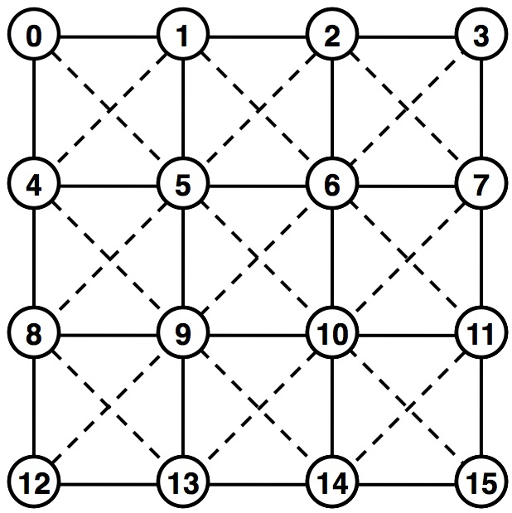 |  | 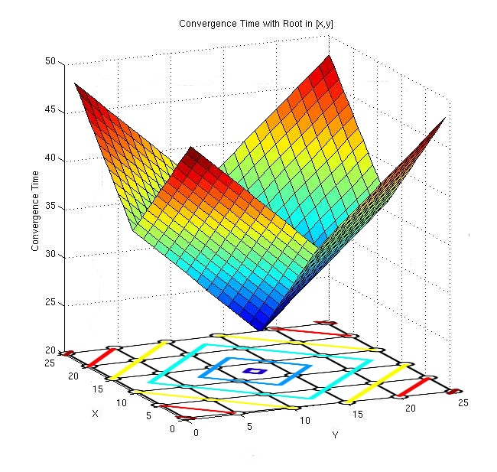
Fig. 3. Grid topologies used  in the analysis | Fig. 4. Convergence time for different  network sizes | Fig. 5. Convergence time for different  Root locations

The firs tests carried out are plotted in figure 4. The continuous line shows executions of the algorithm on a grid network of degree 4 and different topology size (N). As it is expected, the convergence time depends on the size of the network. The larger the topology, the larger the tree to create, and the higher the CT. The dashed line shows the same analysis but using the topology of degree 8. Also as expected, since we are considering normalized hop delays and now the nodes are more interconnected, the CT is lower than the previous case but also grows with the topology size. In these two first analyses, the CT depends on the size of the tree (hence the path the Root propagation must cross) which in turn depends on the network size.
(a) | (b)
Fig. 6. Processed BPDUs (a) and convergence time (b) for different IDs distributions

The second set of tests considers the grid topology of degree 4 with 625 nodes (25 x 25) and different Root locations (see figure 5). The x-y axis represents the physical location of the node (e.g. 0-0 and 24-24 are corners) and the z-axis contains the values of the CT. A point in the x-y plane represents the node where the Root is located, and its value in the z-axis is the CT for this case. It can be observed there is a minimum CT value in the center of the topology and that the highest CT corresponds to the four corners. The reason is that the longest tree branch in this topology always finishes in a corner. When the Root is in the center, the branches are relatively short because the longest branches start in the center and finish in the corners. When the Root is in one corner, the longest branch must reach the opposite corner at the other side of the network. Again as expected, the CT depends on the tree and especially on the length of the longest branch staring at the Root, as the theoretical bound also states.
The last performed tests study the behavior of the algorithm in a fixed topology size (100 nodes and degree 4) and varying the distribution of the IDs of the rest of the nodes. When nodes decide if a BPDU is superior or not the sender bridge ID decides in case of tie (same Root, same cost). Therefore whether a node is connected to a branch or another (hence the final tree) depends on these IDs. We address two different cases always locating the Root in the corner. In the first one each node has the ID that figure 3 shows. In the second one we consider a random distribution of these IDs. Figure 6(a) shows the number of processed BPDUs by each node in the topology (the x-axis represents the nodes, not the ID used to compute the tree). The upper plot corresponds to the consecutive distribution of IDs and the lower one the random one. In the first case, the mean number of processed BPDUs is higher because the propagation waves start at each node and do not completely disappear until they go out of the network. Visually, all wave fronts advance from the concrete node to the bottom-right corner together one after the other. In the random distribution, some of the waves locally disappear because they encounter better opponents and are not propagated any more. Even though this different operation, the CT of each single node, see figure 6(b), is the same in both cases (also the network CT, which corresponds to the latest node to converge). This result reaffirms the expected behavior stating that the CT only depends on the propagation from the real Root node, and especially on the longest branch of the tree.
The theoretical bound of section III can be also used as a reference value to evaluate concrete implementations. The dotted line in figure 4 plots the value of the convergence time of the standard implementation of the STP. The CT linearly grows with the number of nodes N. IEEE STP has a much larger convergence time because it uses an over dimensioned port timer to assure the tree is configured. The value of this timer is configured assuming the hypothetic worst case of a tree with a single branch that connects all nodes (n = N-1, where N is the number of nodes). Note this concrete implementation is oriented to be used in small networks and for small values of N the distance to the theoretical bound is not that large. This behavior changes as the network size is increased, and for this reason the STP needs improvements for the use in large scale Provider networks. On the other hand, the RSTP avoids the difficult decision of detecting the end of the tree configuration and activates the ports as the propagation from the Root advances. A further study of this technique and its behavior in front of failures is planned in immediate future work.

IV. Conclusions
Although the STA is easy to analyze from the single node perspective, the study of its behavior from the network point of view is more complex. This paper provides an explanation of the mechanism that creates the tree and provides a theoretical bound of the convergence time of the algorithm. This value depends on the network topology characteristics and is the lowest bound that can be achieved. It can be used as a reference to evaluate different proposals. For example, the IEEE STP implementation behaves far from this lowest value.
The implementation in the simulation has served to validate the theoretical value and to provide detailed analysis like the number of processed BPDUs. The next step is the addition of the RSTP implementation in order to test its behavior and continue the detailed study towards a solution that meets the 50ms requirement.
Based on the operation of STA, the main conclusion of this study is that the CT only depends on the propagation from the Root (its location and the length of the longest branch).

References
[1] G. Chiruvolu, ”Issues and approaches on extending Ethernet beyond LANs”, IEEE Comm. Mag., vol.42, no.3, pp. 80-86, Mar 2004.
[2] IEEE 802.1D-2004, “IEEE Stdr. for MAC Bridges”, IEEE Std 802.1D-2004 (Revision of IEEE Std 802.1D-1998), pp. 1-269, 2004.
[3] IEEE 802.1D-1998, “IEEE Stdr. for MAC Bridges”, ANSI/IEEE Std 802.1D 1998 Edition, pp.1-355, 1998.
[4] E. Gray, "The Architecture of an RBridge Solution to TRILL", IETF draft, February 2008.
[5] D. Fedyk et. al., “GMPLS Ethernet Label Switching Architecture and Framework,” IETF Draft, February 2008.
[6] R. Perlman, ”A protocol for Distributed Computation of a Spanning Tree in an Extended LAN”, ACM SIGCOMM, 1985.
[7] J.R. Evans, E.Minieka, “Optimization Algorithms for Networks and Graphs”, 2nd edition, Marcel Dekker, ISBN 0824786025, 1992.
[8] E. Bonada, D. Cavic, D. Sala, “Implementation of a L2 Bridge in ns3 (poster)”, Proceedings of SIMUTools 2008, March 4-6, 2008.

